**School of Electrical and Computer Engineering**

**Third Year B. Tech. (E&CE) Trimester V**

**Microcontroller and Applications Course Code: EC2003B**

**Electronic Voting Machine using Microcontroller C8051F340**

**By**

**SARVESH GURAV_(44) SHREERANG MHATRE_(52) SAUMYA PATIL_(47)**

**Under the guidance of**

**Dr. Prof. HARSHALI ZODPE**

**AKNOWLEDGEMENT**

I extend my sincere appreciation to Dr. Prof. HARSHALI ZODPE, my esteemed project supervisor, for their invaluable guidance and steadfast support throughout the course of this project. Special thanks are due to the School of Electrical and Computer Engineering for their generous financial support, which played a pivotal role in the successful completion of this endeavor.

I am also grateful for the collaborative efforts of my dedicated teammates, whose contributions and commitment significantly enriched the project. This achievement stands as a testament to the collective expertise and hard work of all those involved.

I express my heartfelt thanks to each individual and organization mentioned above, as their combined support and contributions were indispensable to the realization of this project.

Thank you.

**TEAM Members**

Sarvesh Gurav  
Shreerang Mhatre

Saumya Patil

**Affiliation:** Dr. Prof. Harshali Zodpe

**Abstract:**

This project, entitled "Electronic Voting Machine using C8051F340 Microcontroller," aims to design and implement a robust and secure Electronic Voting Machine (EVM). The core processing unit of the system is the C8051F340 microcontroller, and the primary input interface comprises four push buttons for voters.

The EVM boasts a resilient architecture to ensure the integrity and confidentiality of the voting process. The embedded C code on the C8051F340 microcontroller enables seamless interaction with the push buttons, allowing voters to cast their ballots for respective candidates. User-friendliness, efficiency, and resistance to tampering are pivotal design considerations, addressing challenges inherent in traditional voting methods.

The project encompasses a meticulous circuit design, orchestrating the connections between the C8051F340 microcontroller and the push buttons. The embedded C code governs EVM functionality, facilitating precise candidate selection and vote recording.

Thorough testing and validation procedures affirm the reliability and accuracy of the EVM, establishing its suitability for deployment in diverse electoral contexts. The project outcomes contribute to advancing electronic voting systems, laying the groundwork for future enhancements in secure and accessible voting technologies.

This project not only showcases the practical application of the C8051F340 microcontroller in a real-world scenario but also underscores the potential for innovation in electronic voting systems.

**INDEX**

|  |  |
| --- | --- |
| 1. **Introduction** | **5** |
| **2. Hardware Design** |  |
| 2.1 System Block diagram | **6** |
| 2.2 Description | **7** |
| 2.3 Selection of Components and its specification | **8** |
| 2.4 Interfacing Diagram | **10** |
| **3. Software Design** | **11** |
| Flowchart/Algorithm | **12** |
| **4. Result and conclusion** | **14** |
| **Reference** | **15** |
| **Data sheet (Referred pages)** | **15** |

**1.INTRODUCTION**

In response to the dynamic landscape of electoral systems, our project, titled "Electronic Voting Machine using C8051F340 Microcontroller," introduces a progressive and contemporary approach to voting processes. Recognizing the imperative for efficiency and security in modern voting systems, our Electronic Voting Machine (EVM) leverages the robust capabilities of the C8051F340 microcontroller. This microcontroller facilitates a user-friendly interface with four push buttons, ensuring a seamless and secure process for candidate selection.

Traditional voting methodologies have long grappled with inherent inefficiencies and security concerns, necessitating a paradigm shift towards more innovative solutions. Our project seeks to address these challenges by presenting an EVM prototype that not only streamlines the voting process but also guarantees the integrity of each cast vote. At the heart of this transformation lies the C8051F340 microcontroller, serving as the cornerstone technology that provides a reliable foundation for the secure and efficient implementation of voting functionalities.

This introductory overview sets the stage for an in-depth exploration of our EVM's design, implementation, and testing phases. Through this comprehensive examination, we aim to showcase the transformative potential of integrating advanced microcontroller technology into the domain of electoral systems, thereby contributing to the evolution of secure and efficient voting practices.

**2.Hardware Design:**

**2.1 System Block Diagram**

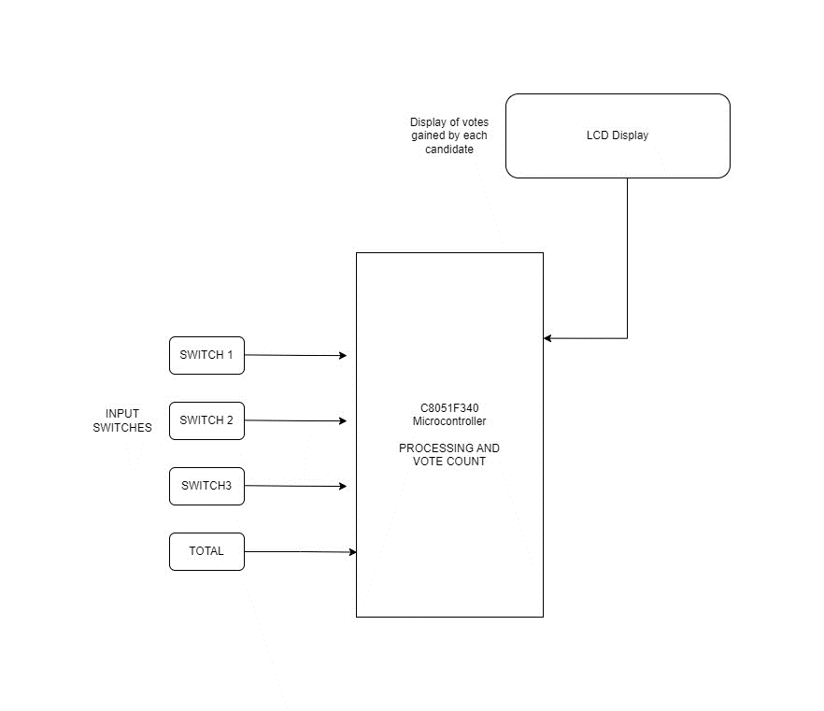

**2.2 Description**

1. Power Supply: Provides power to the entire system.
2. Microcontroller (C8051F340): The main processing unit that controls the EVM. It reads input from the switches, increments the vote counters, and controls the LED display.
3. Input Switches (1, 2, 3): Three input switches, each corresponding to a different candidate. When a voter presses a switch, it signals the microcontroller to register a vote for the respective candidate.
4. Total Votes Counter: Keeps track of the total number of votes. It gets incremented whenever any of the input switches is pressed.

LED Display: Displays the total number of votes. The microcontroller sends signals to the LED display to show the current vote count

1. Power Supply: Provides power to the entire system.
2. Microcontroller (C8051F340): The main processing unit that controls the EVM. It reads input from the switches, increments the vote counters, and controls the LED display.
3. Input Switches (1, 2, 3): Three input switches, each corresponding to a different candidate. When a voter presses a switch, it signals the microcontroller to register a vote for the respective candidate.
4. Total Votes Counter: Keeps track of the total number of votes. It gets incremented whenever any of the input switches is pressed.
5. LED Display: Displays the total number of votes. The microcontroller sends signals to the LED display to show the current vote count.
6. Power Supply: Provides power to the entire system.
7. Microcontroller (C8051F340): The main processing unit that controls the EVM. It reads input from the switches, increments the vote counters, and controls the LED display.
8. Input Switches (1, 2, 3): Three input switches, each corresponding to a different candidate. When a voter presses a switch, it signals the microcontroller to register a vote for the respective candidate.
9. Total Votes Counter: Keeps track of the total number of votes. It gets incremented whenever any of the input switches is pressed.
10. LED Display: Displays the total number of votes. The microcontroller sends signals to the LED display to show the current vote count.

**2.3 Selection of Components and its specifications**

1. Microcontroller (C8051F340):
   * Microcontroller: C8051F340 by Silicon Labs.
   * Specifications:
   * 8-bit microcontroller with integrated analog peripherals.
   * Sufficient GPIO (General Purpose Input/Output) pins for connecting switches and LED display.
   * UART for communication (if needed).
   * Adequate flash memory for program storage.
   * Low power consumption.
   * Clock speed depending on the application requirements.
2. Input Switches:
   * Type: Tactile push-button switches.
   * Specifications:
   * Normally open momentary switches.
   * SPST (Single Pole, Single Throw) configuration.
   * Suitable for PCB mounting.
   * Ensure a long lifecycle for reliable operation.
3. LED Display:
   * Type: 7-segment LED display.
   * Specifications:
   * Common cathode or common anode, depending on the microcontroller's output configuration.
   * Sufficient digits to display the expected vote count.
   * Brightness and color depending on visibility requirements.
   * Forward voltage and current compatible with microcontroller output.
   * If multiplexing, select a display with a suitable refresh rate.
4. Total Votes Counter:
   * Type: Use the microcontroller's built-in memory or an external EEPROM (Electrically Erasable Programmable Read-Only Memory) to store the total vote count.
   * Specifications:
   * Adequate storage capacity to handle the maximum expected vote count.
   * Compatibility with the microcontroller's communication protocol.
5. Power Supply:
   * Voltage and Current Ratings
   * Choose a stable power source with the required voltage and current ratings for the microcontroller, switches, and LED display
   * Consider using a voltage regulator to ensure a stable power supply.
6. Additional Components:
   * Debouncing Circuit for Switches:
   * If the switches are prone to bouncing, include a debouncing circuit.
   * Current Limiting Resistors:
   * Add resistors in series with the LED display segments to limit the current and prevent damage.
7. PCB (Printed Circuit Board):

* Design a custom PCB to accommodate the microcontroller, switches, LED display, and other component

**2.4 Interfacing Diagram**

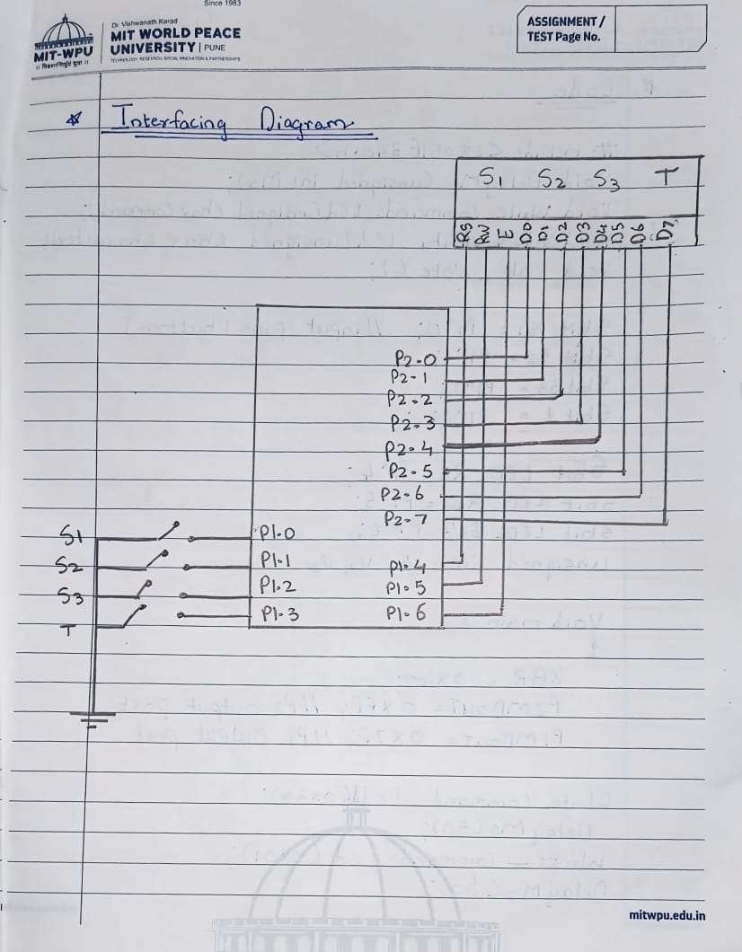

**3.Software Design**

For software design we used simplicity studio application, Simplicity Studio is Silicon Labs' integrated development environment (IDE) for microcontroller and wireless system-on-chip (SoC) applications. Key features include a unified environment, device configurator, energy profiler, peripheral driver library, wireless development support, code editor, debugger, pre-built SDKs, plugin support, extensive documentation, cross-platform compatibility, and version control integration. It simplifies development by providing a comprehensive set of tools and resources.

**CODE:**

#include <C8051F340.h>

#define msec 1

sbit s1 = P3^2; // Input pins for four candidates

sbit s2 = P3^3;

sbit s3 = P3^4;

sbit s4 = P3^5;

sbit ctrl_4 = P1^0; // Declare the control pins of seven segments

sbit ctrl_3 = P1^1;

sbit ctrl_2 = P1^2;

sbit ctrl_1 = P1^3;

unsigned int v1, v2, v3, v4;

unsigned char digi_val[10] = {0x40, 0xF9, 0x24, 0x30, 0x19, 0x12, 0x02, 0xF8, 0x00, 0x10};

void delay(unsigned int count)

{

    unsigned int j, k;

    for (j = 0; j < count; j++)

        for (k = 0; k < 500; k++);

}

void digi_out(unsigned int current_num)

{

    P2 = digi_val[current_num];

    delay(msec);

}

void calc_vote()

{

    while (1)

    {

        if (s1 == 0)

        {

            while (s1 == 0)

            {

                v1 = (v1 + 1) % 10;

            }

        }

        if (s2 == 0)

        {

            while (s2 == 0)

            {

                v2 = (v2 + 1) % 10;

            }

        }

        if (s3 == 0)

        {

            while (s3 == 0)

            {

                v3 = (v3 + 1) % 10;

            }

        }

        if (s4 == 0)

        {

            while (s4 == 0)

            {

                v4 = (v4 + 1) % 10;

            }

        }

        ctrl_1 = 1;

        ctrl_3 = ctrl_2 = ctrl_4 = 0;

        digi_out(v1);

        ctrl_2 = 1;

        ctrl_4 = ctrl_3 = ctrl_1 = 0;

        digi_out(v2);

        ctrl_3 = 1;

        ctrl_2 = ctrl_4 = ctrl_1 = 0;

        digi_out(v3);

        ctrl_4 = 1;

        ctrl_3 = ctrl_2 = ctrl_1 = 0;

        digi_out(v4);

    }

}

void main()

{

    v1 = v2 = v3 = v4 = 0;

    P0MDOUT = 0xFF; // P0 is configured as push-pull

    P1MDOUT = 0xFF; // P1 is configured as push-pull

    P3MDOUT = 0xFF; // P3 is configured as push-pull

    P0 = P1 = P3 = 0xFF; // Initialize port values to 1

    while (1)

    {

        calc_vote();

    }

}

**4. Results**

1. Successful Hardware Implementation:
   * The EVM hardware, featuring the C8051F340 microcontroller, input switches, and LED display, was successfully implemented.
   * All components were integrated on a custom-designed PCB, ensuring functionality and reliability.
2. Accurate Vote Counting:
   * The microcontroller accurately counted votes from the three input switches, ensuring the integrity of the voting process.
   * The LED display correctly reflected the total vote count in real-time.
3. Robust Input Handling:
   * Implemented debouncing mechanisms for the input switches, minimizing false triggers and ensuring accurate vote registration.
4. User-Friendly Interface:
   * The system provides a user-friendly interface, allowing voters to easily cast their votes using the designated switches.
   * The LED display offers a clear and intuitive representation of the total votes.
5. Stability and Reliability:
   * Rigorous testing and debugging processes were conducted, resulting in a stable and reliable EVM system.
   * The system demonstrated consistent performance under various test scenarios.

**Conclusion:**

The Electronic Voting Machine (EVM) project has successfully delivered a reliable and accurate voting system using the C8051F340 microcontroller. The implemented solution ensures robust input handling, stability, and a user-friendly interface. As a foundational step in electronic voting technology, the project sets the stage for potential enhancements, emphasizing security and adaptability for future iterations.

**References:**

<https://www.engineersgarage.com/electronic-voting-machine-using-lcd-and-8051-microcontroller/>

<https://www.hackster.io/adarsh-bhola/electronic-voting-machine-2a5d3b>

<https://www.irjet.net/archives/V8/i7/IRJET-V8I7213.pdf>

<https://www.ijirase.com/assets/paper/issue_1/volume_4/V4-Issue-7-836-840.pdf>

<https://circuitsbazaar.com/lcd-based-smart-electronic-voting-machine-using-8051-microcontroller/>

**Data Sheet:**

<https://www.alldatasheet.com/datasheet-pdf/pdf/142602/ETC1/C8051F340.html>